

APPENDIX 1

SPECIFICATION DOCUMENT
FOR THE SUPPLY OF
FILTER BELT SYSTEM

FOR

Quinto Plasterboard Plant,
Spain

CONTRACT REFERENCE:

10190-C50-TSP-GMT-001 Rev B

SCOPE OF SUPPLY

Scope Overview

The scope of this tender supply covers:
- The design, manufacturing, packaging and site delivery of a Vacuum Filter Belt system, including any required auxiliary equipment for continuous, safe operation and testing of both input and output streams. The details of the specification are discussed in section 2. of this document.
This scope will include:
- The specification and design of:
  - A continuous flow Vacuum Filter Belt, including:
    - Filter Belt Frame and supports for all Filter Belt equipment, instrumentation, and piping.
    - Filter Belts, both heavy duty support filter belt and filter belt cloth for primary dewatering process.
    - Slurry Material distribution system, to distribute the slurry material as evenly as possible across the filter belt.
    - Filter Belt Scrapper/cleaning system for removal of cake material into the product outlet.
    - Wash water spray system and containment box for the cleaning of the belts and prevention of water leakage into cake output.
    - Belt tensioning system
    - Belt alignment and correction system
  - A Steam extraction system to remove steam/humid air from above the filter belt including extraction fan.
  - A Vacuum Pump Skid to provide the vacuum for removing the water from the Slurry to form the cake, with a heat exchanger for cooling of Vacuum Pump sealing water.
  - A Vacuum Separator to separate air/water mixture pulled by the Vacuum pump.
  - Auxiliary equipment, required for the function of the above-mentioned systems or for other uses such as transporting material streams between different equipment solutions or back to the existing equipment lines for reuse.
  - Sampling systems for the extraction and testing of the various streams in the different processes, both to allow for manual monitoring of the process as required as well as environmental testing if needed.
- Creation of detailed equipment specifications for the system above in line with Saint-Gobain Documentation and equipment naming systems (See Documents 10190-AP0-EPP-GMT-001 OTO Quinto Document Identification, 10190-C50-EPP-GMT-001 OTO Quinto Filter Belt Equipment Identification Specification), including:
  - Modification of Process Flow Diagram (10190-C50-DFL-GMT-001 – PFD – Dewatering Overview) showing major equipment with expected operational values.
  - Equipment Line Diagrams (ELDs) and/or Piping & Instrumentation Diagrams (P&IDS) of each Equipment system, or sub-systems if the system is complex enough to require segregation for clarity and understanding.
  - Supply of Input/Output Electrical list for each equipment system.
  - Supply of equipment dimensions, layout and loading information.
  - Supply of Recommended Spare Parts List
- Sourcing and Assembly of equipment detailed above at Supplier site in a manner suitable for a Factory Acceptance Test (FAT) as detailed in Section 4 of this Specification.
  - All equipment must be painted in line with the Project Standard colours (See 1500-AP0-TSP-GMT-002 Equipment Paint Colours), so provision for paint application must be made by the supplier to do this at their site if required.
  - All carbon steel piping, components and structures must be painted to the designated standard (See Engineering Standard 1555-AP0-TSP-GMT-003 Equipment Paint Application Method) to remove the risk of wear and damage.
  - The FAT may be split into multiple dates to accommodate shipping and installation requirements of different pieces of equipment, particularly in cases where a lot of piping is to be inspected. This will be agreed with the Contractor as part of the tender negotiation.
  - Supply of piping and equipment insulation where required, both from high temperature material (up to 100 degrees) which are within ‘easy’ reach, and for potential site winter conditions.
    - High Summer temperatures at site must be considered when specifying insulation thickness.
    - The insulation should not be installed at the Suppliers site where possible, to avoid potential damage during transportation/installation.
- Seaworthy Packing of the equipment and spare parts in a suitable manner to prevent damage during transport (See Section 5 of this Appendix)
    - Provision of protective measures to avoid damage must be considered, especially to delicate components during transport and initial installation. These measures are to include protective plastic covers and / or removal of instruments for separate packaging for later site installation.
  - Transportation of all items to the Site (DAP). It is required that Supplier provides option costs for Ex-Works and FOB (Nearest Port).
  - Quotation line for site visits to provide training for both operation and maintenance of equipment to site team so that the equipment can be operated without direct support.

Auxiliary Scope Considerations

The scope of work should also include, but is not necessarily limited to:
- Provision of suitable lifting lugs or other means of handling the equipment for installation.
- Provision of all fasteners (including holding down bolts) and gaskets.
- All pneumatically powered equipment is to be rated to 8 bar g, and the connection type is to be 8 mm. If this is not possible for an equipment item, then the Purchaser must be alerted.
- Provision of equipment and piping identification tags to make installation and recognition easier on site according to the Purchaser specification (1500-AP0-TSP-GMT-012 Specification for Equipment Labelling).
- Provision of Support visits/meetings to ensure the Civil, Utility and Electrical/Automation requirements for the Filtration Equipment systems is fully understood and designed by the relevant sub-teams/contractors.
- Supply of Manufacturing Models and Drawings required for the placement in a 3D model for layout and civils purposes. If these Documents cannot be supplied by the Contractor, it should be clearly stated as part of the quotation.

Spares

Joined to the present specification is a Purchaser Spare parts List. (See Document Register).

The Contractor shall provide Purchaser with a complete itemized list of all recommended spare parts (and consumables) with Contractor’s name and address, original manufacture article number, product name and any information required to purchase the spare parts and consumables from the Original Equipment Manufacturer (OEM).

The list will clearly identify the items that are:
- Recommended for installation and/or commissioning.
- Long lead (>6 weeks) or difficult to source reliably.
- Spares required for long term maintenance/machine reliability.
For Piping and other items where nuts, bolts and other connectors are required, it is expected that spares of these small items are ordered to at least 10% of the scope total to ensure that there is sufficient available on site for installation.

This is to be discussed as part of the tender agreement between Contractor and Purchaser and the final % value is to be updated before the signing of the contract.

Documentation

10190-C50-TSP-GMT-001 Appendix 6- Belt Documentation specifies the documentation expected to be provided for the equipment in the scope mentioned above. It is expected that this will include:

- All relevant documentation relevant to the operation and day to day maintenance of the equipment.
- Process Description and/or a control methodology for each equipment system as well as documentation required to satisfy local and international standards (See Appendix 6: Documentation).
- A list of any Corporate Social Responsibility (CSR) initiatives the Contractor currently takes part in, or any CSR initiatives that the Contractor will join in the period of the work being undertaken during the project timeline.
- Contractor documentation related to Environmental & Sustainability of their supply chain including independent ratings (e.g., Eco Vadis or similar).
- CE marking Declaration of Conformity for each system, including all supporting documentation required.
- Any additional documentation required by ISO or Country standards as required by the associated legislation.
In addition, the Document Register (10190-C50-PDT-GMT-001 OTO Quinto Belt Document Register.xlsx) shall be considered as a reference for the technical document revisions to consider throughout the project. It references in it all necessary Documents with their latest released versions to be considered for the tender but also, at a later stage, for manufacturing.

SPECIFIC EQUIPMENT REQUIREMENTS

Equipment Systems

Filter Belt-

The Filter Belt is expected to dewater a continuous stream of Gypsum Slurry (See data Sheet (10190- B91-TDS-GMT-002), separating the Slurry into a liquid stream and a solids stream for further processing and recycling into previous processes as required.

The basic design criteria are as follows:

- Slurry throughput- 50 – 70 TPH (41-55 m3/h).
- Slurry moisture content- 40-50 %
- Slurry Temperature (Input)- 90-110 °C
- Cake Moisture Content- <10 %
- Filtrate Water Solids Content- <1 %
- Wash Water Inlet Solids Content- <0.5%
- Wash Water Outlet Solids Content- <0.5%
- Wash Water Supply Temperature- 25 °C.
- To prevent the risk of material build-up on the scraper over production and potential contamination or damage to the Filter belt cloth, it is required that a double scraper system is put in place, to allow for the removal/cleaning of one scraper during operation.
- Due to the settling and setting nature of the reacted gypsum, it is required that all surfaces that can contact the material are angled at least 15 % and can be cleaned easily with water during operation. The cleaning with water can either be by an automated cleaning system or using cleaning ports where manual cleaning with pressure washers can be applied.
- To assist in clearing any build-up or blockages that occur over time, it is required that cleaning ports are to be included in the design of all piping (T-Ports instead of 90-degree bends, removable cleaning sections of ~1 m pipe are to be included every ~15 of straight piping etc.).
- If it is required for the Wash Water to be of a higher temperature, then this should be highlighted to the Purchaser in the Quotation for approval.
- It is required that instrumentation for the measurement of the height of the pooling slurry at the inlet of the Filter Belt on both the Left- & Right-hand sides, so that the distribution of the slurry can be monitored for abnormal operation.
- It is required that instrumentation for the measurement of the height of the cake at the outlet of the Filter Belt on both the Left- & Right-hand sides, so that the distribution of the cake can be monitored for process control and quality purposes.
- Due to the risk of high temperature material and human contact with roller/belt nip points, the Belt filter is required to be enclosed with mesh guarding according to ISO/EN and Purchaser Standards (1500-AP0-TSP-GMT-007 Machine Guarding Standard). It is required that the mesh is painted in line with Purchaser Visual Standard (1500-AP0-TSP-GMT-013 Visual Standards).
  - Guarding is to be secured to prevent access to the interior of the Filter belt assembly without the use of tools.
  - Guarding is to be manufactured so that each piece of guarding weighs less than 20 kg and is provided with lifting handles to allow a single person to lift and remove them.
  - Guarding at the outlet of the Filter belt is to be designed to include access points for taking cake samples and inclusion of a Moisture Transmitter.
- It is expected that the equipment to transfer, monitor and provide information for all three material streams (pumps, storage tanks or similar, instrumentation and switches) are included in the scope of this equipment system.

Vacuum Separation-

The water is ‘pulled’ through the belt by vacuum, and the combined water and air stream is pulled through a vacuum box(es) and must be separated before the air is pulled to the Vacuum Pump.

Therefore, the liquids are removed from the gas stream using a separator.

The basic design criteria are as follows:

- Input-
  - Flowrate (Liquids): 26 TPH (TBC)
  - Maximum Solids: >1%
  - Temperature: 75+ (TBC)

As the Separator and the Filtrate Output are outside the previous stated Filter Belt Assembly guarding, it is required that the separator and the piping connected to it are insulated to prevent additional risk from high temperature.

It is expected that the equipment to transfer, monitor and provide information for all three material streams (pumps, storage tanks or similar, instrumentation and switches) are included in the scope of this equipment system.

Vacuum Pump Skid-

The Vacuum pump skid must include:

- Vacuum Pump (size determined by the Filter Belt Requirement)
- Vacuum Separator
- Heat Exchanger for Vacuum Pump cooling water recirculation
- Vent piping from separator to external vent

All the above equipment, as well as required valves and piping, are to be supported on a single equipment skid. This skid is to be designed to allow for lifting with a Fork Lift truck from underneath as well as by lifting lugs as required.

Electrical & Control System

All equipment is to be specified according to the following requirements:

Voltage: 400 VAC (Large/control equipment), 24 VDC (Sensors/Switches)
Control system: Siemens units and controllers
Control Type: See document 1555-W00-DSP-TIP-002 Electrical Supplier List.

All items are to be specified in the IO list for each equipment system to ensure that this can be reviewed and approved by the Purchaser.

If an item of equipment cannot match these requirements this is to be highlighted to the Purchaser directly, as well as highlighted in the IO list of the submission.

An item that is not matching these requirements can only be ordered with the express written permission of the Purchaser.

General Specifications

- All manual valves shall be delivered with a lockable handle, unless otherwise specified by the Purchaser.
- All manual valves to be selected with PTFE seat.
- All manual ball valves shall be 3-part dismountable valves.
- Material for seals and elastomer parts in contact with the fluid: For each system, refer to drawings, MSDS and Equipment List. In case of discrepancy, please contact the Purchaser for clarification.
- For all Equipment, the Purchaser supplied drawings have to be modified to “As Built” drawings based on final components provided.
- For drawing revisions, refer to the Document Register

Gaskets for flanged connections

- Material: For each system, refer to drawings, MSDS and Equipment List. In case of discrepancy, please contact the Purchaser for clarification.
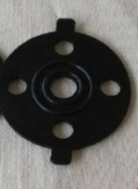
- All gaskets to be with the following shape:

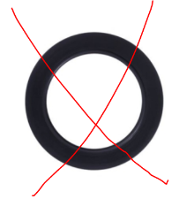

The following shape is not accepted:

The Contractor shall implement a clear identification system allowing the Purchaser to easily identify the seal materials:

An example from a former project:
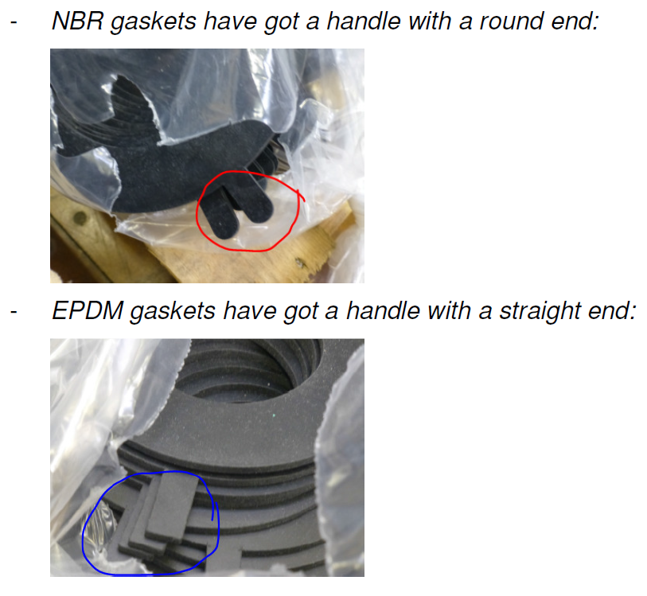
Such an identification system is acceptable. However, a system displaying the material name or first letter on the gasket would be preferred.

Manufacturing Schedule

A project programme will be issued shortly after receipt of the purchase order to confirm design and fabrication duration, FAT test date and delivery. A critical path for manufacturing shall be identified at the start of the project and supplied to the Purchaser in charge for validation.
Implementation of specific designs will require detailed discussion with the successful Contractor, and will include the following points:
- Ensuring instrument displays are at a uniform height and facing in the correct direction.
- Ensuring valve handles are the correct colour. If the valves are bought with the same colour for all handles, then the Contractor has to change the colour of the handles (by painting or another method to be validated by the Purchaser) to adapt them to the Purchaser’s specification for valve handle colours (indicated in the Equipment Summary List ‘Other Specifications’)
- Allowance for space for operational and maintenance activities around all equipment, valves, and instrumentation.
- Alterable coloured gauge displays to show safe zones (green) and unsafe zones (red), that can be modified on site after commissioning.
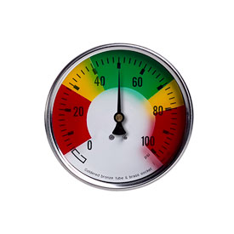
Note: If not already supplied by the Contractor, a guard around the coupling gear motor/pump or gear motor / agitator shall be supplied.

GENERAL REQUIREMENT & STANDARDS

The following set of mechanical standards will be considered during fabrication of the Equipment. The Contractor shall be responsible for the correct application of these standards.

- 1500-AP0-TSP-GMT-002 - Equipment Paint Colours
- 1500-AP0-TSP-GMT-003 - Equipment Paint Application Method
- 1500-AP0-TSP-GMT-005 - General Standard for Basic Mechanical Equipment Requirements
- 1500-AP0-TSP-GMT-006 - Standard for Equipment Documentation
- 1500-AP0-TSP-GMT-007 Machine Guarding Standard
- 1500-AP0-TSP-GMT-009 - Standard for Pneumatic Equipment
- 1500-AP0-TSP-GMT-011 - Lubrication Identification Specification Sheet
- 1500-AP0-TSP-GMT-012 - Specification for Equipment Labelling – Identification
- 1500-AP0-TSP-GMT-013 – Visual Standards

In addition to the above standards, the Contractor should comply with following:

- All Equipment should be design & built to Sound Engineering Practice (SEP).
- Contractor must include the first fill of lubricants. All oil filled equipment should include a level indicator.

FACTORY ACCEPTANCE TESTS

FAT CRITERIA

The completed Equipment shall be inspected by the Purchaser prior to despatch from the Contractor’s works.

The Contractor will ensure the following be made available:

- Electricity = 400V AC, 3ph, 50Hz
- Compressed air = 10 bar g

Resource to aid the Purchaser in the setting up and carrying out of testing has to be included.

Testing at works shall include, but not be limited to, the following points:

- ‘Dry’ Run test of all valves, instrumentation and any auxiliary systems for function, position on fail etc.
- Water tightness test of all rated equipment and piping. Water to be of a quality compatible with stainless steel for hydraulic testing and components to be thoroughly drained and dried afterwards.
- Flow Tests of all pumps and corresponding flowmeters or similar instrumentation by drop test to ensure flow range before arrival on site.

The Contractor shall provide a completed log of all tests for the Purchaser. The log shall include verification of compliance with the Specification. The Purchaser reserves the right to witness the tests if require.

Before Packing, all Equipment shall be thoroughly cleaned internally and externally to remove all dirt or other foreign material.

PLANT MARKING, PACKING AND TRANSPORTATION

- All packing cases shall have the gross weight clearly identified and a full inventory enclosed.
- A detailed Packaging list of all items being shipped must be generated and provided to the Purchaser. This list must include all details of equipment being packed, including which packing case it is stored in to aid unpacking and installation.
- Special handling instructions shall be conspicuously placed on all equipment, packing cases requiring unusual handling and shipping care.
- The Contractor shall protect all machined surfaces and threaded connections against corrosion and mechanical damage.
- All open pipes, tanks and equipment nozzles shall be fitted with protective blanks.
- All Equipment that will be exported from its place of manufacture shall be suitably packed for transportation to the final site; where overseas transport is involved the equipment shall be suitable weather proofed to prevent the ingress of moisture during outside storage (Seaworthy packaging) and un-painted surfaces prone to oxidation need to be protected.
- The Contractor shall be responsible for loading and adequately anchoring the Equipment in the packaging to prevent damage during transit to the designated delivery point.
- All loose items like bolts, studs, nuts, gaskets, etc. shipped separately shall be suitably packed to prevent damage during transit. These items shall be clearly marked with the equipment tag reference number.

