Instruction for arrival of goods, Project FENIX
Logistics Database in PIMS
- It is required that all shipments into FENIX is entered into PIMS

The PIMS database is:
- A tool to enable proactive follow up logistics into Rönnskär-FENIX.
- A tool to plan activities for unloading, and other logistics activities and help minimize waiting time for trucks.
- An easy-to-use overview of deliveries and shipping documents.
- A user-friendly program to add information.
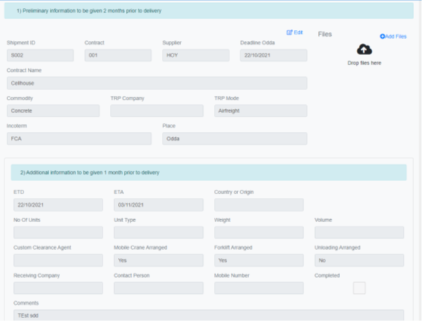

- Please provide a contact list with names & e-mail addresses for those who needs access and training on how to use PIMS Logistics Database.

Marking of goods
All orders of goods to be delivered to the project site shall be clearly and visibly marked with reference and contract number for reception, on waybills and delivery note.
If the goods require special arrangements for storage such as weather protection, this shall also be specified on the delivery note.
For goods with incomplete marking and neglected delivery instructions an investigation fee will be charged.
Delivery notes / waybills shall be marked with reference for reception:
Company: Name of company Workplace: Name of workplace
Contact person Name of Supervisor on site Phone no. Ph.No. to named Supervisor

Goods shall be marked with  Project Fenix  Company and Contact person.  Number of units in the shipment  Bolidens IO number (Purchase Order No)  Tagnumber |  | Delivery Address  Boliden Mineral Project Fenix  Näsuddsvägen 14 C/O Northlink  932 33 SKELLEFTEHAMN

Delivery instructions
Delivery of goods shall be organized to regular opening hours (Mon – Fri 07.00-16.00). Other hours only on exception.
48hrs Prealert shall be sent to fenix.logistics@boliden.com minimum 2 days prior to ETA. At least 2 hours before goods will arrive to Rönnskär, driver shall advise the arrival by calling +46910-77 31 32 Driver’s name and phone number, registration number on the vehicle
- Name of receiving company and contact person (incl. Phone no) as specified in delivery note.
- Type of goods and type of equipments needed for unloading of goods
- Estimated time of arrival
If the truck have full load that shall be unloaded on site he will be escorted by warehouse personnel to correct place on site.

Goods Reception
Goods Reception, located beside the project area site. The storage has a dedicated area for unloading goods. Larger deliveries can be unloaded on the site, guided by Fenix project contact person.
Supplier/contractor is responsible for and pays for transportation to the project area site. Boliden personnel in goods reception at the project area site, will perform inspection on goods for indication of transport damage, documenting with camera and reporting to project contact person.
48 hrs - Prealert
To be mailed 48hrs prior to arrival to: Fenix.logistics@boliden.com
Shipper
Reciever company
On site receiver contact name
On site contact mobile number
Contract / PO number
Transport company
Driver name
Driver’s mobile number
License plate
Estimated time of Departure (ETD)
Estimated time of Arrival (ETA)
Unloading place
Unit no. | Number of colli | Weight | Volume | Unloading arranged: Yes/No

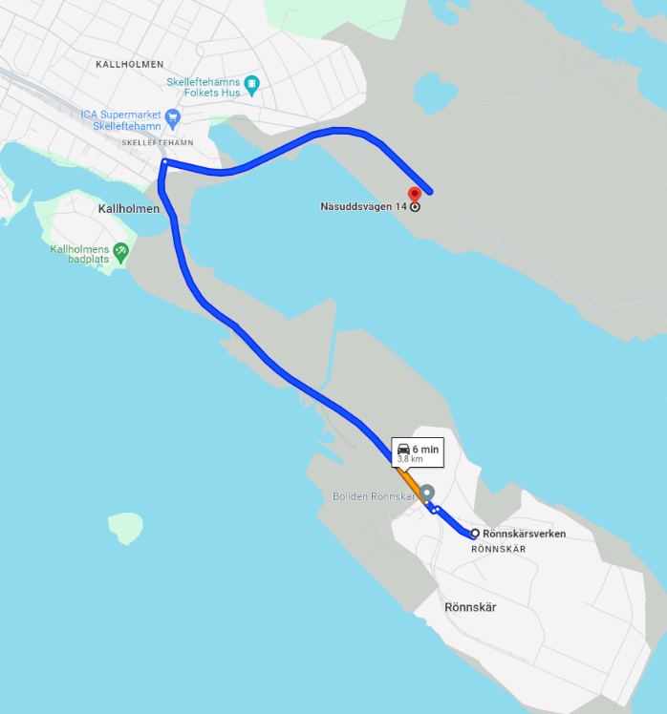
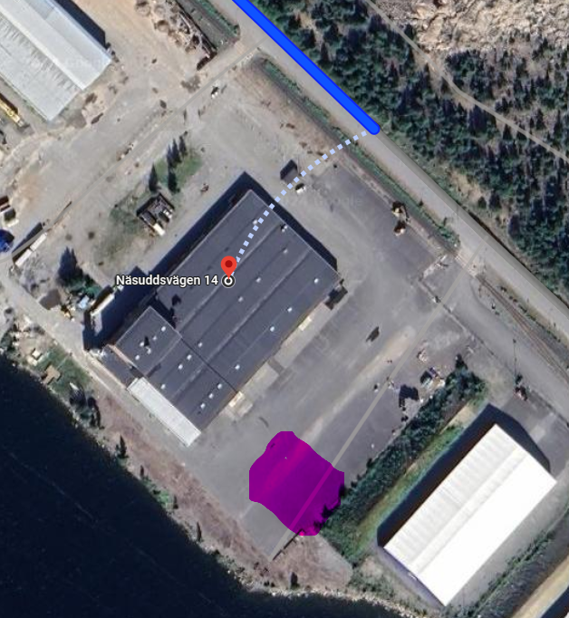
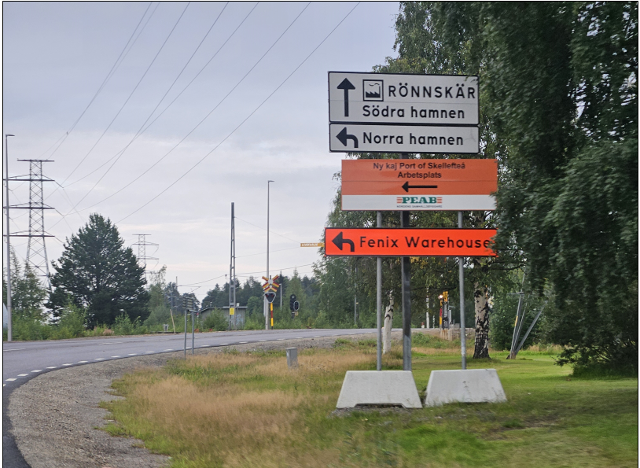
Signs on Järnvägsleden where to turn to road Näsuddsvägen

